**#CODE**

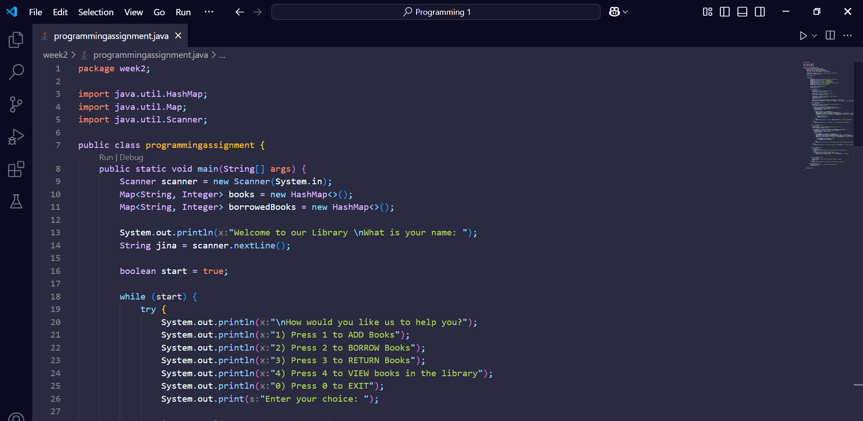

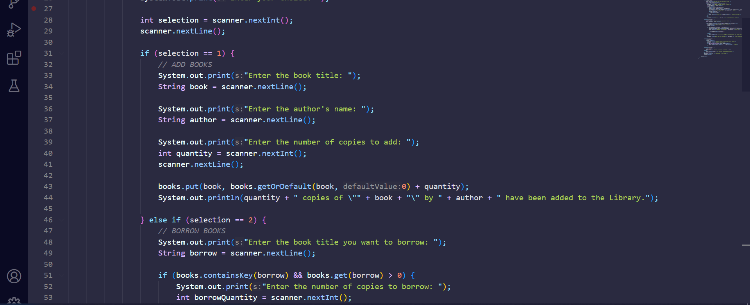

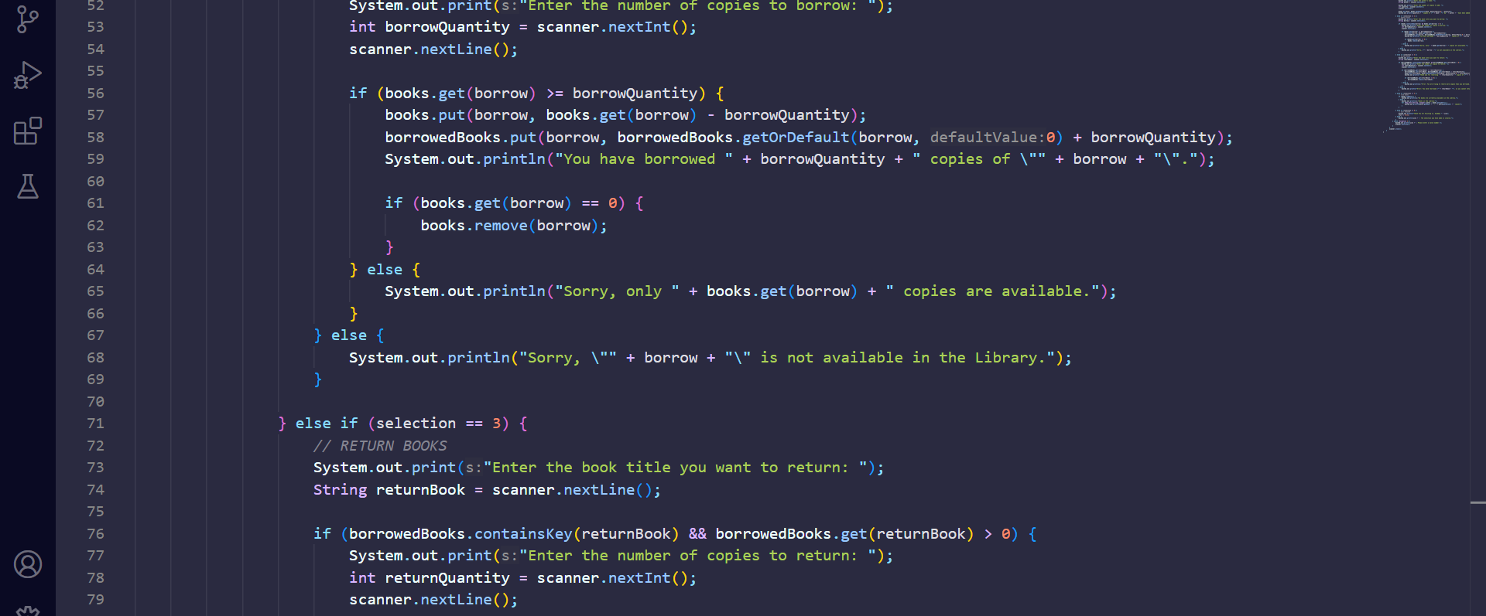

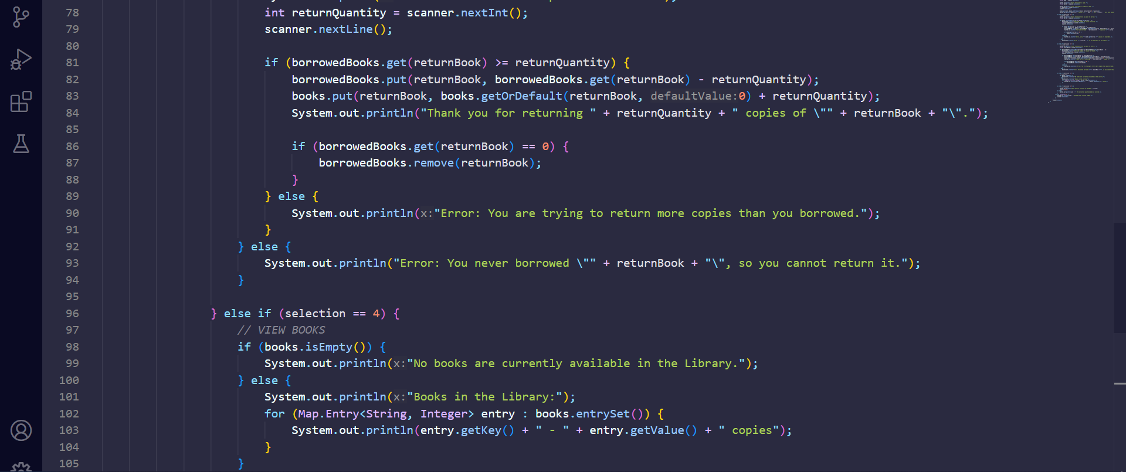

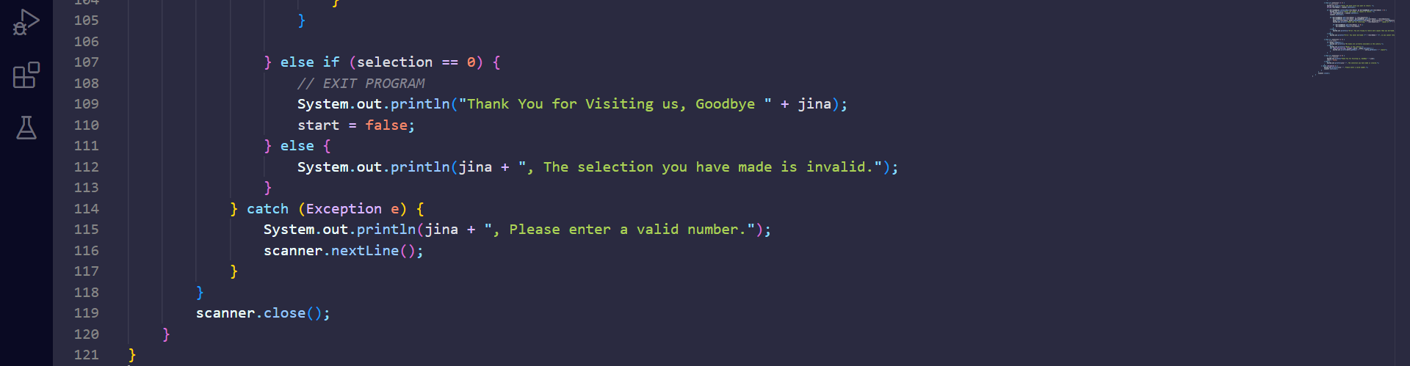

**#OUTPUT**

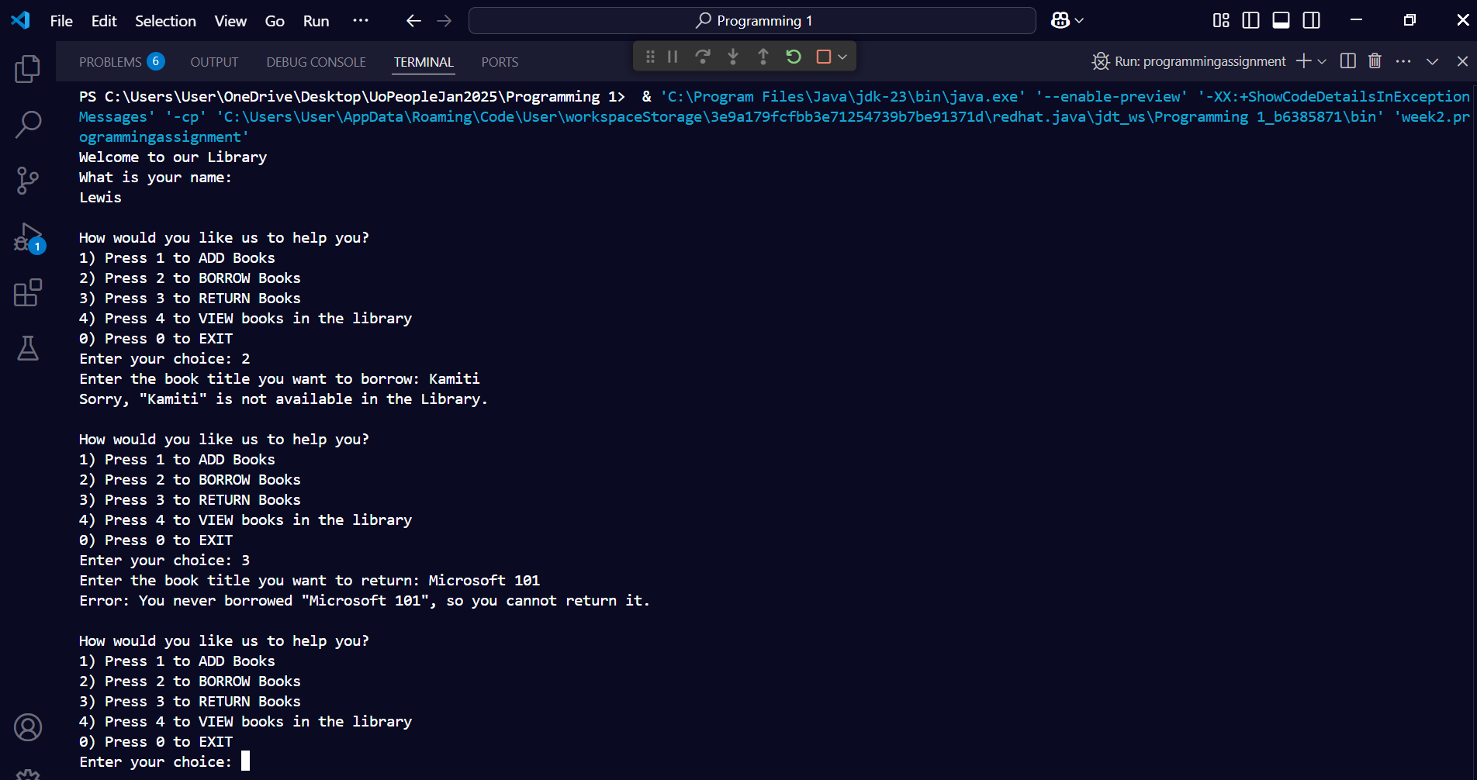

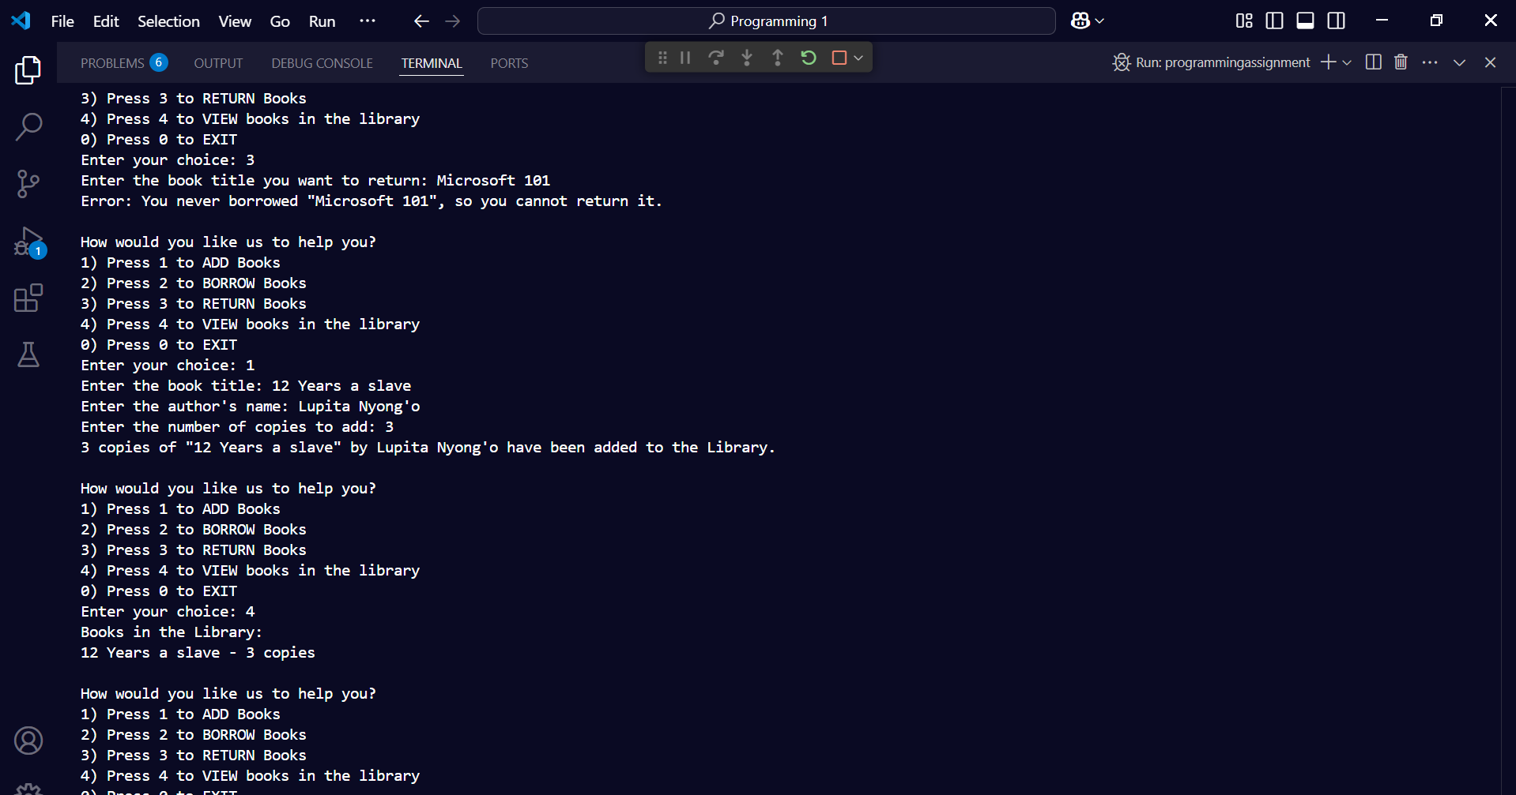

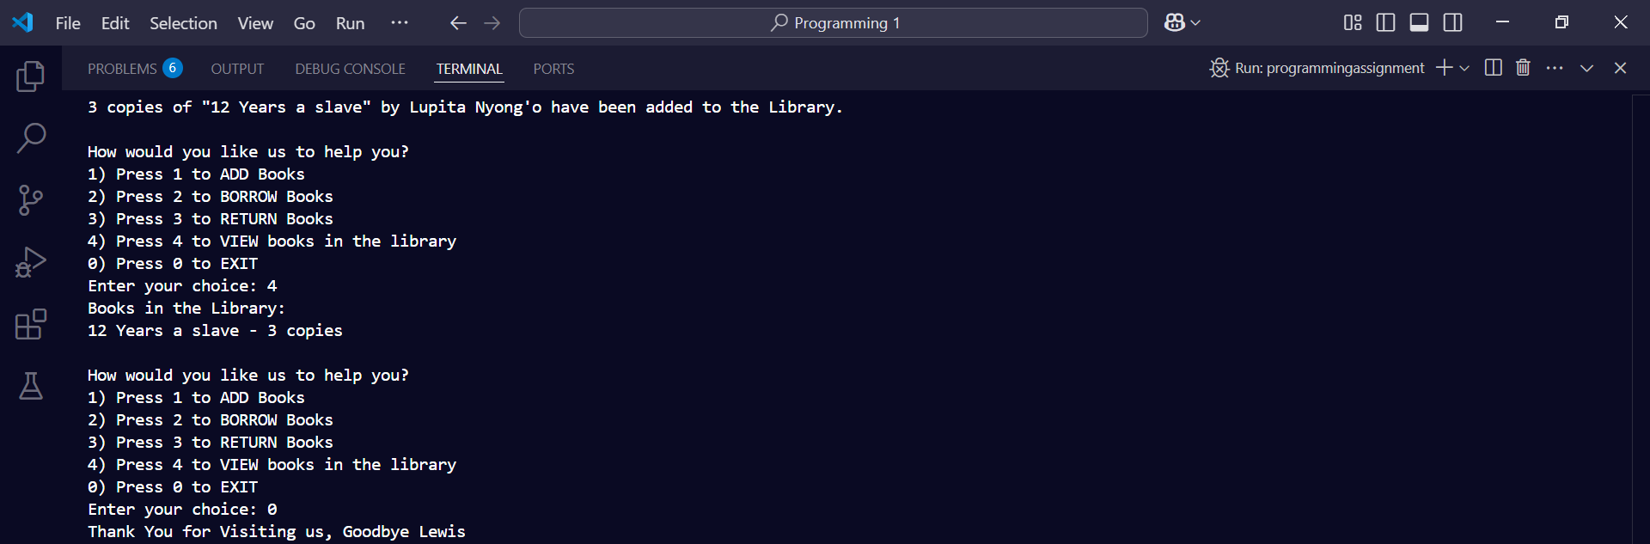

### **Program Explanation**

This Java program implements a simple library management system that allows users to:

1. **Add Books** – Add books to the library, updating quantity if the book already exists.
2. **Borrow Books** – Borrow books if available, reducing the quantity in the library.
3. **Return Books** – Return only books that were previously borrowed, updating the quantity.
4. **View Books** – Display the list of books available in the library.
5. **Exit** – Terminate the program.

This Java program functions as a basic library management system, allowing users to add, borrow, return, and view books. It starts by asking for the user’s name and then presents a menu with different options for interacting with the library. The book inventory is stored using a HashMap, where book titles serve as keys and their quantities as values.

When a user adds a book, they must enter the title, author, and quantity. If the book already exists in the library, the system updates its quantity instead of duplicating entries. Borrowing a book requires the user to specify the title and number of copies. The program verifies if enough copies are available before adjusting the inventory. If the book is unavailable or the request exceeds the available quantity, an error message is shown.

For returning books, the system ensures that users can only return books they have previously borrowed. If a user tries to return a book they never borrowed or returns more copies than they initially took, the program notifies them of the issue. Users can also view the library’s inventory, which lists available books and their quantities.

The program effectively manages user input, preventing invalid selections and errors while ensuring smooth interactions. It continues running until the user chooses to exit, at which point a farewell message is displayed. This system provides a structured way to handle books in a small library.